Nguyễn Minh Thành

20529120

MSIS3030.N22.CTTT

**LAB02’S REPORT**

***EX1: Open Exercise 6 on Lab 1, Create and assign resource***

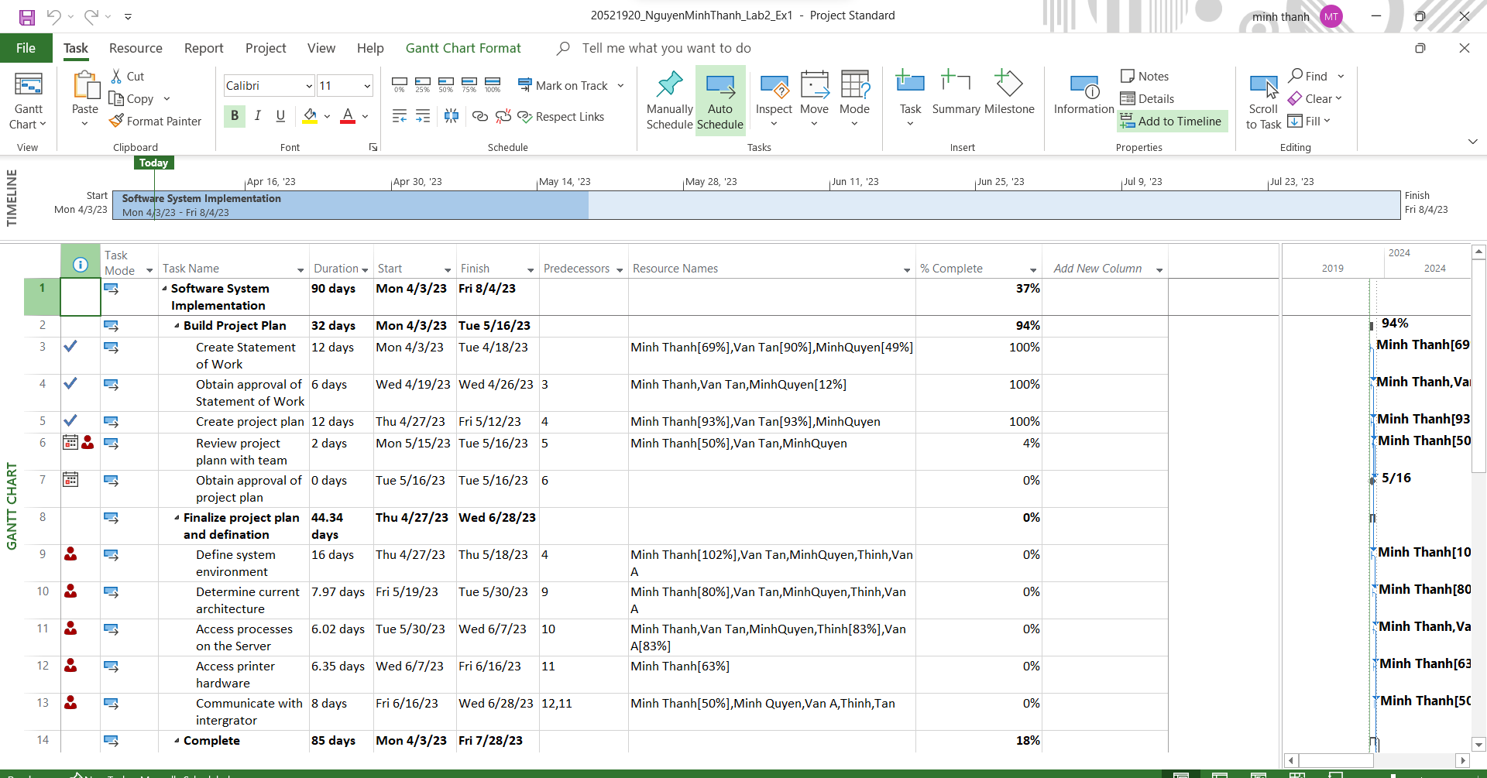

***EX2: Create milestones as below based on Exercise 3 – Lab 1***

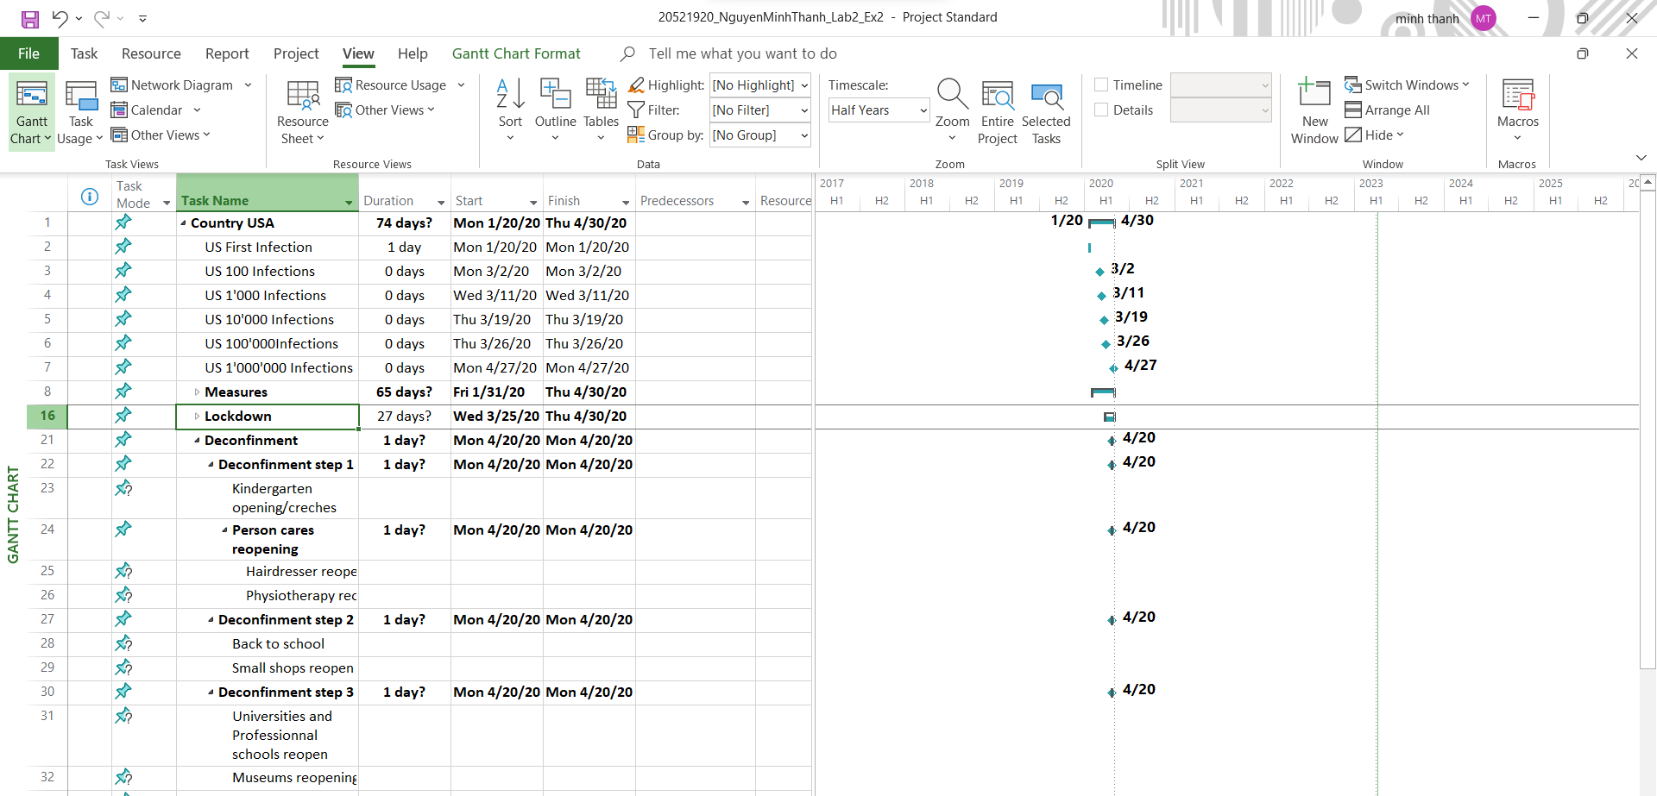

***EX3: Convert MS Project WBS below to the chart form***

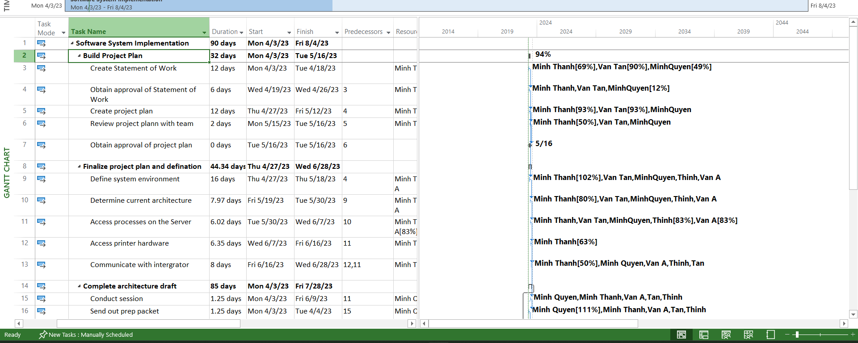

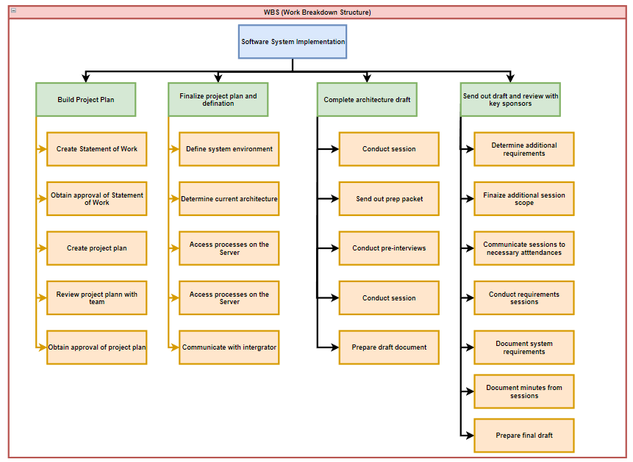

***EX4: Convert chart form below to the MS Project WBS***

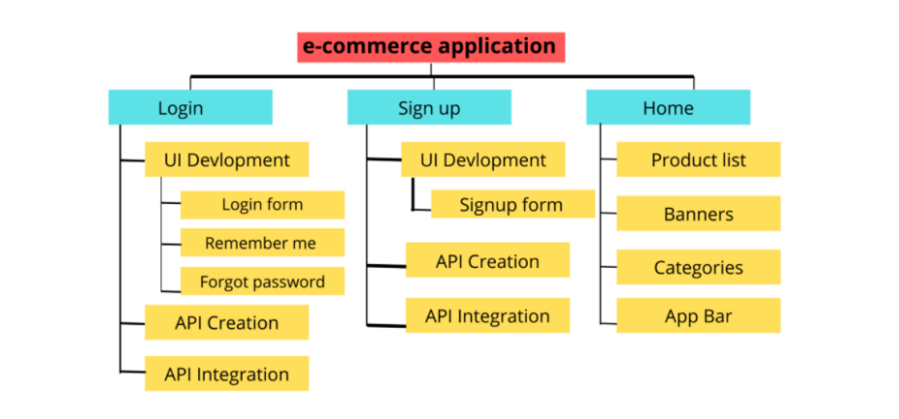

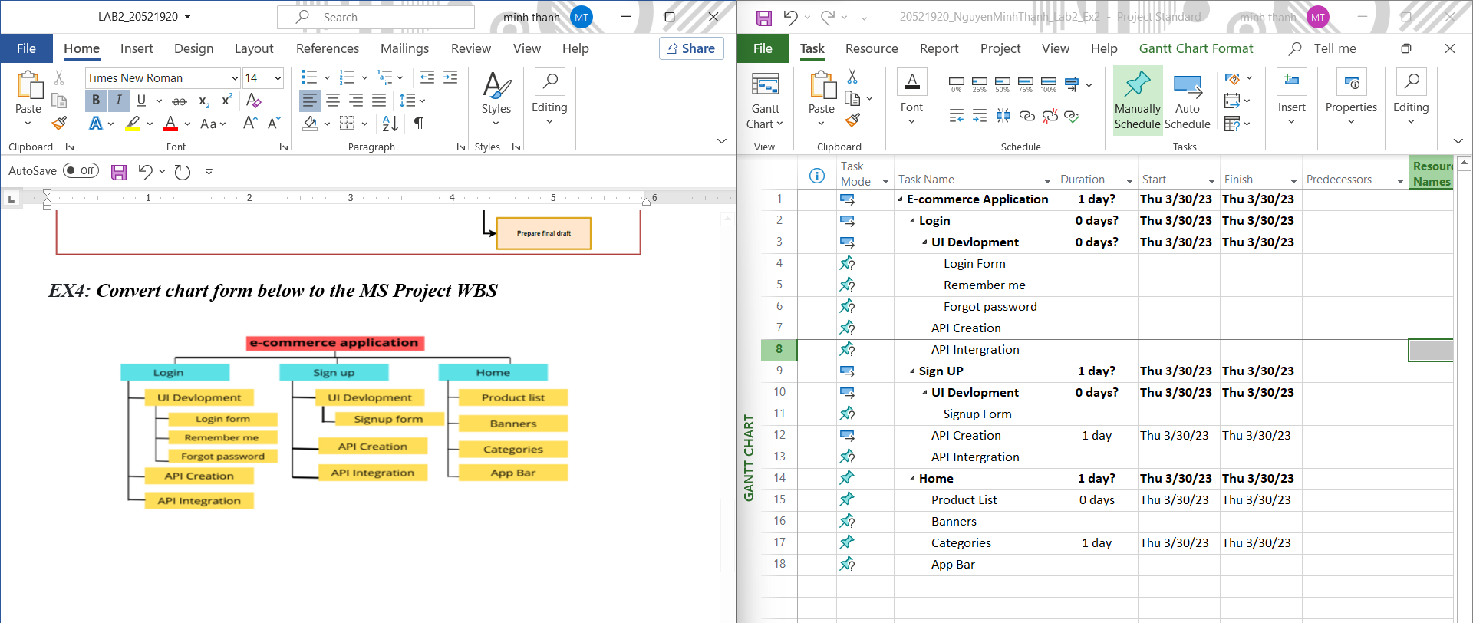

***EX5: Draw this WBS Chart form and convert it into MS Project WBS***

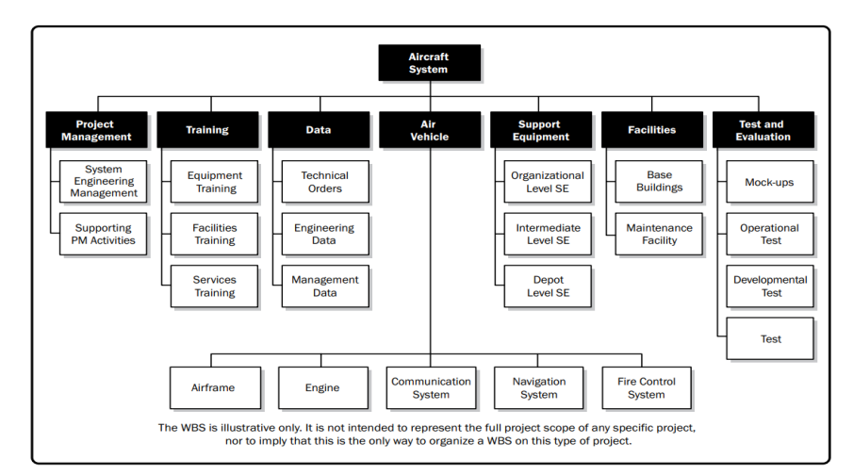

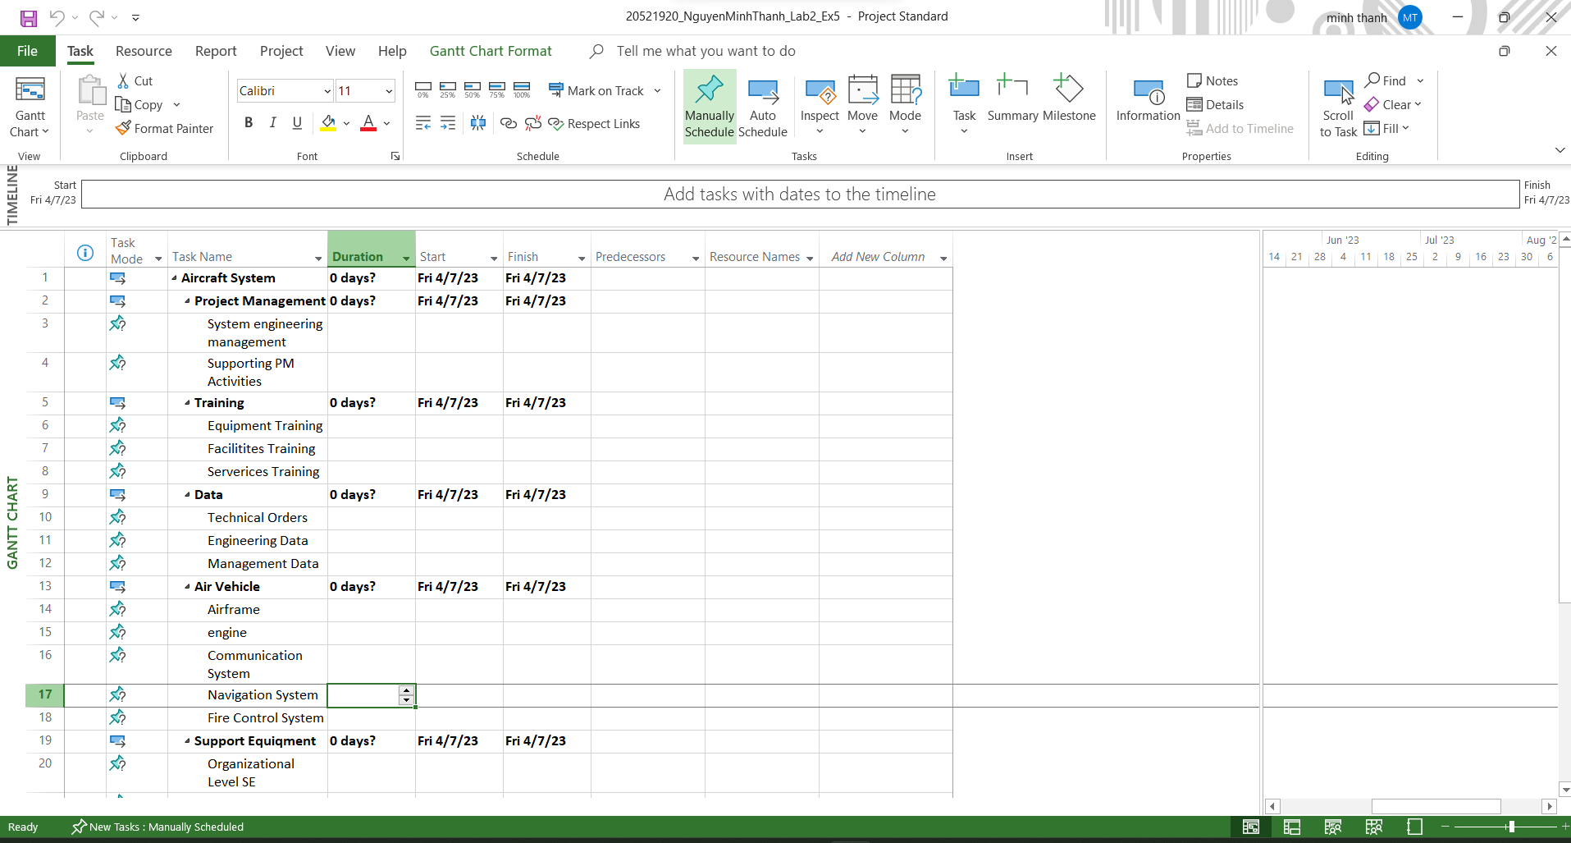***EX6: Create WBS Dictionary of Exercise 3 as this format***

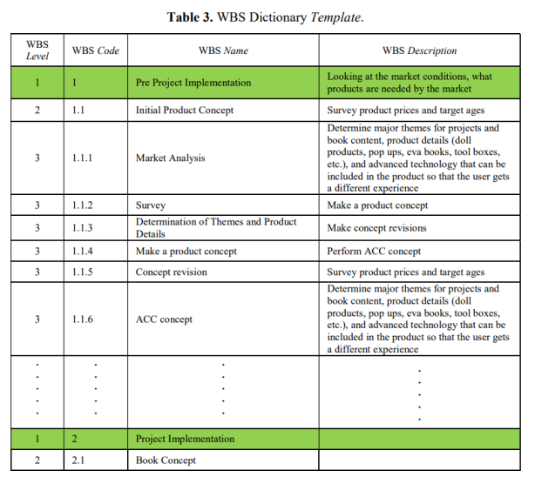

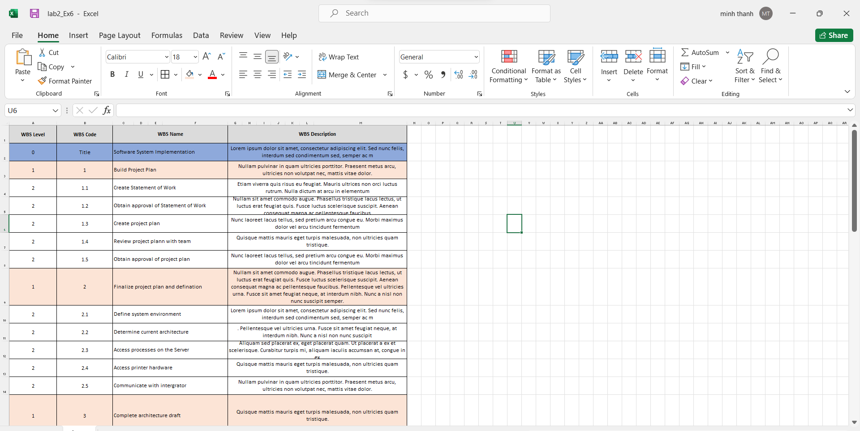

***Link drive :***

***https://drive.google.com/drive/folders/1M7b-ZqltMhbpXMXsWtHHLOTKAz2ozHp6***